### [AP06-AA7-EV06. Inglés Taller: “Reconociendo el lugar de trabajo”.](https://senaintro.blackboard.com/webapps/assignment/uploadAssignment?content_id=_108166712_1&course_id=_2042066_1&group_id=&mode=view)

Husney Bayona Rincón

Alejandra Patricia Tobar Mendoza

### 2019

SENIGRAT

**INTRODUCCIÓN**

En este documento se realiza la actividad [AP06-AA7-EV06. Inglés Taller: “Reconociendo el lugar de trabajo”](https://senaintro.blackboard.com/webapps/assignment/uploadAssignment?content_id=_108166712_1&course_id=_2042066_1&group_id=&mode=view), respondiendo a los casos dados.

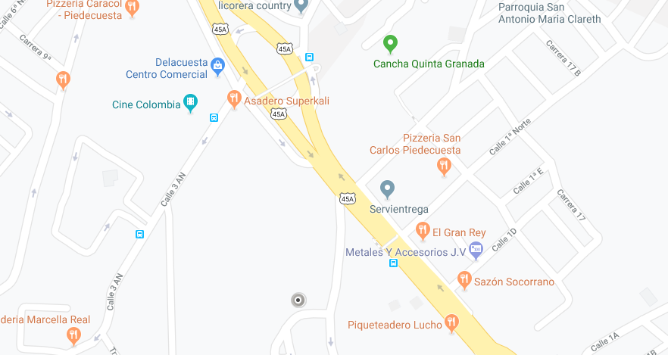

my place of study is in my house, i live on a fifth floor, its located at the top left of my town, my town is called piedecuesta, it's a place that i like a lot since i have a shopping center located on the left at that i like to visit when i go to watch movies with my family or friends or hang out, a sports center located on my right where i go with friends to jog and exercise, there is a gasoline in front of my house, a residential complex behind my house, the main park is located to the central right of my house which is the park where they do the events, and i like to meet with my family in that place and have a family time, in the central left part fint most of the fast food places and in the upper left is located in a place well known by my people called los hermitaños, where many people gather to exercise in a capillary that sits on top of the mountain, and have a lunch.

**Instructions**

You have been recently promoted to be Assistant Manager at the company you work for and one of the things you are responsible for is dealing with employee issues to try to solve unpleasant or potentially threatening situations in your workplace.

This week the Human Resources Assistant Manager has submitted to you the following two cases of employees who are somehow involved in bad attitude problems or bullying issues.

Read each case carefully and complete the related tasks or exercises.

**Case 1**

**A short story about conflict in the workplace**

*John had a great team, but one employee in particular just had a bad attitude. This was an employee John inherited when he became manager. This employee was always negative, did not act as part of a team, and was arrogant in every way. John talked to this employee to try and inspire and encourage (including documenting this verbal warning), but after a short period of time, the employee fell back into their usual ways.*

*Only a few weeks after John spoke to the employee, a loud disagreement between this employee and another happened on the main floor. It was loud enough to have people stop in their tracks wondering what was happening. John immediately went to the floor, and calmly asked each employee to stop by his office. He talked to them about how conflict in the workplace is unacceptable, gave a verbal warning for one of the employees, and a written warning to the employee with the bad attitude stating that if this behavior continues, suspension and/or termination would be the next step taken. These warnings were done separately as not to embarrass each employee.*

*It was a bit of a shock to the employee with a bad attitude that a written warning was given, however, John made it perfectly known that this was not the first time they met because of this team-affecting behavior. John also was not quite as caring as he was at the first meeting. He took out the notes from the last meeting and went over what was discussed, including that a written warning would be given if the behavior continued. With this documentation, the employee had no choice but to accept the written warning.*

*That put a scare into the employee, who from that point on had no more attitude issues. The employee’s personality and character stayed the same, but there were no more negative comments or further disruptions (Masterclassmanagement.com, 2017)*

*.*

**According to the previous information, answer the following questions.**

1. What is the problem with John’s employee?

1. John’s employee is always late for meetings at work.
2. John’s employee is bullying his co-workers all the time.
3. John’s employee has attitude issues and displays a negative behavior to colleagues.
4. John’s employee doesn’t obey his orders.

1. What event caused John to make the decision of giving a verbal and written warning to his problematic employee?

1. John’s employee had a loud disagreement with one of his co-workers
2. John’s employee was way too arrogant.
3. John’s employee did not act as part of a team.
4. John´s employee didn’t change his behavior.

1. Was this the first time John’s problematic employee had a team-affecting behavior?

1. Yes, it was the first time he had a disagreement with a co-worker.
2. Yes, he had no attitude issues before
3. No, other team-affecting behavior episodes were documented before.
4. No, he has received several written warnings before.

1. In the sentence «*That put a scare into the employee»,* the expression **to put a scare into** can be replaced by:

1. To persuade
2. To encourage
3. To punish
4. To warn

**According to the case introduced above, decide whether the following statements are true (T) or false (F).**

|  |  |  |  |
| --- | --- | --- | --- |
|  | | T | F |
| 1 | John had a problematic and conflictive work team. | x |  |
| 2 | John’s problematic employee was recruited before he was appointed manager. | x |  |
| 3 | When the disagreement between John’s employees happened, he gave both of them verbal warnings and suspended them. |  | x |
| 4 | Since John gave his problematic workers a written warning, he had no more attitude issues. |  | x |
| 5 | After the episode, the employee’s personality and character changed dramatically. | x |  |

Now, answer in a simple and short paragraph, what you would have done to find a solution to the previous employee situation.

|  |
| --- |
| The first thing i would do would be to talk to the employee who has a bad attitude to do things and try to make him see better points of view so that he improves his behavior, giving support and encouraging teamwork, with socialization fires with his co-workers. , and try to reduce all problems caused by bad attitude and arrogance, encouraging a better working environment |

**Case 2**

**A depressing situation at work**

*Sara, 23, was consistently getting bullied by a co-worker at the office. It made her workplace environment incredibly uncomfortable, and she found herself getting less and less work done. She also experienced a heavy feeling of anxiety before heading to the office and often called in sick to avoid the issue all together. Instead of quitting her job, Sara decided to find a therapist with whom to work. She learned that she did not have to accept the current office environment as her reality, and identified what steps to take to feel more comfortable at work. To communicate her feelings at the office, she had an open conversation with her boss about why her work is suffering, and organized a meeting with her co-worker and boss to be mediated by the therapist. After a series of enlightening discussions, Sara feels now more confident about going in to work and dealing with co-workers, who are treating her with a newfound respect* *(Therapy and Issues, 2017).*

**According to the previous information, answer the following questions.**

1. What was the problem Sara experienced at work?

1. She was bullied by a colleague.
2. She suffered from an anxiety episode.
3. She wants to quit her job because she found herself getting less and less work done.
4. She could not communicate her feelings at the office.

1. What consequences caused this problem for Sara’s performance at work?

1. She could not get her work done the same way as before.
2. She experienced a constant fear of meeting her colleagues.
3. She wanted to quit her job.
4. She started to have bad attitude problems.

1. What did Sara used to do to avoid going to the office and dealing with her co-workers?

1. She worked from home.
2. She talked to her boss to notify her resignation.
3. She called in sick to avoid going to the office.
4. She found a therapist.

1. In the sentence «*She called in sick to avoid the issue all together»,* the expression **to call in sick** means:

1. If you call in sick, you telephone the place you work at to say that you are unable to work because of illness.
2. If you call in sick, you go to the hospital to get a treatment.
3. If you call in sick, you go to work no matter how sick you are.
4. If you call in sick, you make an excuse for not going to work.

**According to the case introduced above, decide whether the following statements are true (T) or false (F).**

|  |  |  |  |
| --- | --- | --- | --- |
|  | | T | F |
| 1 | Sara was getting bullied by her boss. |  | x |
| 2 | Sara decided not to quit her job because of her problem at work. | x |  |
| 3 | Sara learned that she had to accept the current office environment as her reality |  | x |
| 4 | To open up about her feelings at the office, Sara arranged a meeting with her co-worker and boss to be mediated by a therapist. | x |  |
| 5 | Sara’s situation changed positively after all her efforts to overcome her bullying problem. | x |  |

**Now, explain how you would have handled Sara’s situation from your Assistant Manager position’s point of view.**

|  |
| --- |
| Trying to encourage good attitude and try to understand and improve the work environment, as a resource as time goes by would take larger measures as a therapist. |